Exploration
In the 15th century, Europeans began to sail west across the Atlantic Ocean in search of new routes to China and the East, but in the process, they discovered an entirely New World: North and South America, plus many other lands.
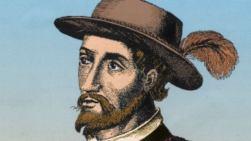

Juan Ponce de León

Juan Ponce de León

CONTENTS
- Early Life and Career of Juan Ponce de León
- Exploration of Puerto Rico and Search for Bimini
- Ponce de León in Florida
- Fountain of youth
- Where was he killed?
Born into Spanish nobility, Juan Ponce de León (1460-1521) may have accompanied Christopher Columbus on his 1493 voyage to the Americas. A decade later, he was serving as governor of the eastern province of Hispaniola when he decided to explore a nearby island, which became Puerto Rico. In pursuit of a rumored fountain of youth located on an island known as Bimini, Ponce de León led an expedition to the coast of what is now Florida in 1513. Thinking it was the island he sought, he sailed back to colonize the region in 1521, but was fatally wounded in a Native American attack soon after his arrival.

Early Life and Career of Juan Ponce de León
Born in 1460 into a noble family in León, Spain, Juan Ponce served as a page in the royal court of Aragon. He later became a soldier, fighting in the Spanish campaign against the Moors in Granada. After that war ended, he may have gone along on the second voyage to the West Indies led by Christopher Columbus in 1493.
Did you know? Juan Ponce de León died in Cuba, but his remains were later transferred to San Juan, Puerto Rico, where they were put to rest in San Juan Cathedral. Puerto Rico's third-largest city, Ponce, bears the explorer's name.
Nearly a decade later, he was serving as a captain in the force commanded by Nicolás de Ovando, Spain’s royal governor of the island of Hispaniola (present-day Haiti and the Dominican Republic). After Ponce de León suppressed a mutiny by Indigenous Americans, Ovando rewarded him with the governorship of the eastern province of Hispaniola.

Exploration of Puerto Rico and Search for Bimini
Rumors of large amounts of gold to be found on the nearby island of San Juan Bautista (as Puerto Rico was then known) drove the Spanish crown to give Ponce de León permission to explore the island in 1508-09. (He may have unofficially traveled there on his own before that.) On the official expedition, he took 50 soldiers and a single ship and founded a settlement at Caparra, near what is now San Juan. When he returned to Hispaniola for supplies, Ponce de León was named governor of Puerto Rico, though he had many rivals for influence and was soon displaced.
Encouraged by the Spanish crown to discover more lands, Ponce de León decided to follow rumors he had heard from local Natives about an island known as Bimini, home to a magical spring or fountain whose waters would rejuvenate those who drank from it. In search of this “fountain of youth,” as well as more lands and gold, he set sail from Puerto Rico in March 1513. The following month, the expedition landed on the coast of what is now Florida, near the site of modern-day St. Augustine.

3. Ponce de León in Florida
At the time, Ponce de León thought that he had landed on another island, and not the coast of mainland North America. He named the site Florida, not only because they landed around the time of Easter (Pascua Florida in Spanish), but also in honor of the region’s lush and florid vegetation. On that first expedition to Florida, Ponce de León explored the coast, including the Florida Keys, and discovered the Gulf Stream, the warm ocean current that would help future Spanish ships maneuver their way home from the New World. He then returned to Puerto Rico and made his way to Spain, where he was named military governor of Bimini and Florida and given permission to colonize the region. The Spanish crown also ordered him to organize an army to subdue a native uprising on Puerto Rico, and he sailed with a small fleet in mid-1515.
In February 1521, Ponce de León departed San Juan on his second expedition to Florida, accompanied by two ships and around 200 people. They landed on the southwest coast of Florida, near what is now Charlotte Harbor, with the intention of founding a colony. The exact circumstances of what happened next are uncertain, but it appears that in early July local Natives attacked the party of settlers, leaving Ponce de León fatally wounded by an arrow in his thigh. His comrades sailed back with him to Havana, Cuba, where he died.

This painting by Austrian artist Eduard Veith shows a scene at the mythical Fountain of Youth. Throughout history, people have sought magical ways to restore their youth.
PHOTOGRAPH BY FINE ART PHOTOGRAPHIC LIBRARY/CORBIS

4. Fountain of Youth
A mythical fountain capable of preserving life has been a popular legend for centuries.
During his twilight years, American author Mark Twain noted that "life would be infinitely happier if we could only be born at the age of 80 and gradually approach 18."
Twain's quip was only one of many complaints about aging that have been recorded for as long as humans have dreaded the downside of a long life. The ancient Greek poet Homer called old age "loathsome," and William Shakespeare termed it "hideous winter." Oscar Wilde's character Dorian Gray even preserved his youth by aging only in a painting, to hideous effect.
So it's not hard to understand why there have always been hopes and rumors that something soon to be discovered—magic waters, say, or maybe stem cell research—will do away with old age.
Alexander the Great, who conquered most of the known world before he died around 323 B.C., may have been looking for a river that healed the ravages of age. During the 12th century A.D., a king known to Europeans as Prester John supposedly ruled a land that had a river of gold and a fountain of youth.
But the name linked most closely to the search for a fountain of youth is 16th-century Spanish explorer Juan Ponce de Leon, who allegedly thought it would be found in Florida. In St. Augustine, the oldest city in the U.S., there's a tourist attraction dating back a century that purports—albeit in a tongue-in-cheek way—to be the fountain of youth that Ponce de Leon discovered soon after he arrived in what is now Florida in 1513.
There are a couple of problems with labeling St. Augustine's natural spring as Ponce de Leon's fountain of youth, however. Elderly visitors who drink the spring's sulfur-smelling water don't turn into teenagers. And Ponce de Leon probably wasn't looking for such a fountain and may not have set foot near present-day St. Augustine. Many historians now think he came ashore about 140 miles (225 kilometers) farther south, near present-day Melbourne, Florida.

The Thrill of the Chase?
But the tale of the search for a fountain of youth is so appealing that it survives anyway, says Ryan K. Smith, a professor of history at Virginia Commonwealth University in Richmond, commenting on the nature of mystery.
"People are more intrigued by the story of looking and not finding than they are by the idea that the fountain might be out there somewhere," Smith says.
No original documents survive from Ponce de Leon's Florida expedition. There is one theory that Spanish historians, writing long after he died in 1521, may have created the story that he was seeking the fountain to make fun of him because he was an old man who wanted to restore his sexual vigor, Smith says.
Still, a few grains of truth have helped sustain the story. Kathleen Deagan, a professor of archaeology at the University of Florida in Gainesville and a National Geographic Society grantee, says a cemetery and the remains of a Spanish mission dating back to St. Augustine's founding in 1565 have been discovered near the so-called fountain of youth.
"It's always been interesting and ironic that the site is, in fact, one of the most important historical sites in Florida," Deagan says.
Michelle Reyna, a spokesperson for the Fountain of Youth Archaeological Park in St. Augustine, says the fountain has been a tourist attraction since at least 1901, and may have been attracting visitors since 1860.

Historian says Ponce de León was killed in Florida, but not where we originally thought
ST. PETERSBURG — James MacDougald believes he has rewritten Florida history and added further intrigue to the early story of the Tampa Bay area.
St. Augustine, founded in 1565, is considered the first successful European settlement in what is now the United States.
But it has long been assumed that, in 1521, Charlotte Harbor was where Juan Ponce de León, the Spanish explorer and supposed seeker of the Fountain of Youth, was mortally wounded while failing to establish the first European settlement.
Now, MacDougald contends that rare German reprints of 500-year-old Spanish maps point to Safety Harbor as the locale.
“These maps change everything,” MacDougald, a St. Petersburg resident, said.
MacDougald’s evidence is compiled in his book, titled The Maps that Changed Florida’s History, to be released either later this year or early next year.
The research was born out of his work authoring another history book, The Pánfilo de Narváez Expedition of 1528: Highlights of the Expedition and Determination of the Landing Place, released in 2018.
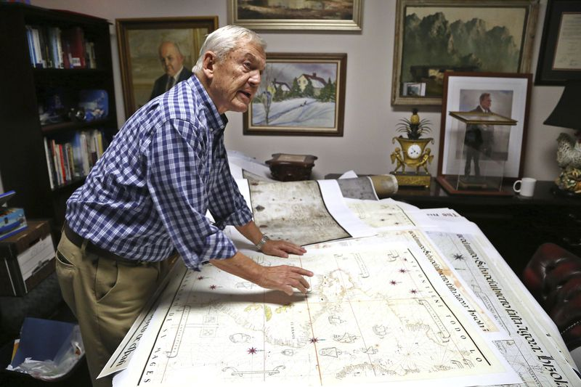
James MacDougald shows off rare maps of the New World from 1527 and 1529 that include the Gulf Coast and Florida., on Oct. 14, 2020, in St. Petersburg, Fla.. According to MacDougald, explorer Juan Ponce de Leon visited Tampa Bay in 1521. He sought to establish the first colony in the U.S. at Tampa Bay, but it did not materialize. According to MacDougald, the first permanent colony in the U.S. was established at St. Augustine in 1565. (Scott Keeler/Tampa Bay Times via AP) (SCOTT KEELER/AP)
In 1528, Pánfilo de Narváez led a failed attempt to colonize Florida for the Spanish government. Around 300 men began the journey but Native American attacks, starvation, disease and other natural causes killed all but four.
“It was a disaster,” MacDougald said.
His book further solidified the belief that the Narváez expedition began in Boca Ciego Bay, off the shore of what is now St. Petersburg.
“In my research, I noticed that they had gone to Safety Harbor and found European artifacts and many boxes from Castile,” the northwestern region of Spain where Ponce de León was born, MacDougald said. “I thought ‘Gee, nobody’s ever really proven where Ponce de León attempted his 1521 settlement.”
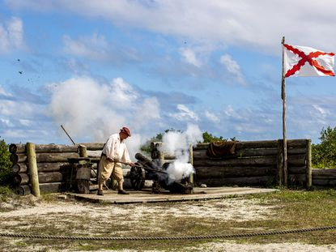
The Charlotte Harbor area has been fingered as the location because it is where Ponce de León landed during his first expedition to Florida in 1513. Historians figured he returned there during his second visit in 1521.
“It pre-dated the Jamestown colony and the Pilgrim landings by nearly a century, and the establishment of St. Augustine by a quarter of a century,” a historic marker in Charlotte Harbor reads. But it also says the “exact location” of the settlement is a mystery.
“There is really no evidence it was ever there,” MacDougald said. But perhaps Narváez found items in Safety Harbor that belonged to Ponce de León’s settlement.
The Tampa Bay History Center’s Rodney Kite Powell said the standing theory is that those items came from a Spanish shipwreck rather than a settlement.
Jerald Milanich, curator emeritus at the Florida Museum of Natural History, has seen MacDougald’s full research and is intrigued by the possible link to Ponce de León.
“Were they left behind by Ponce?” Milanich said of the boxes. “They well could have been. That is something not considered before.”
MacDougald’s quest led him to rare reprints of two Spanish maps that predate the return of the four from the Narváez expedition.
One map was released in 1527 and the other in 1529.
Each can be founded folded into a rare mid-19th century history book published in Germany.
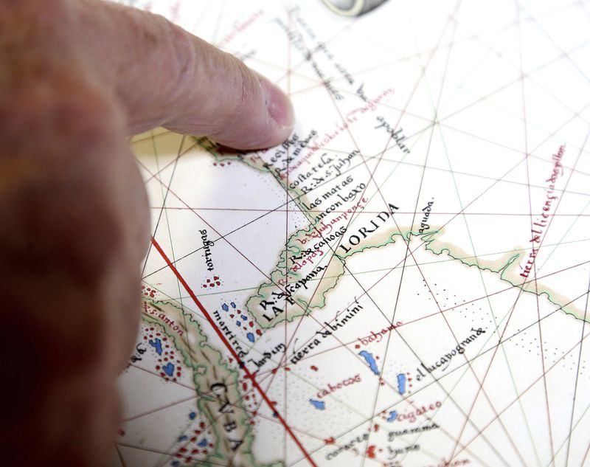
James MacDougald shows off rare maps of the New World from 1527 and 1529 that include the Gulf Coast and Florida, on Oct. 14, 2020, in St. Petersburg, Fla. (Scott Keeler/Tampa Bay Times via AP) (SCOTT KEELER/AP)
“There are 45 copies of the book in the world,” MacDougald said. “I found one for $3,000.”
The maps are around 2x3 foot and “the whole Gulf of Mexico area is only 2x2 inches with teeny, teeny, teeny, teeny, teeny little writing spelling out 60 names in that area,” MacDougald said. “So, I had that section scanned and blown up. I then measured the longitude and latitudes.”
At 27.5 degrees latitude, where Tampa Bay is known to be located today, the maps say, "Bahía de Juan Ponce,’ Spanish for Juan Ponce Bay.
“Bahía de Juan Ponce is certainly Tampa Bay,” said Milanich, who had previously heard of the Bay of Juan Ponce via Spanish accounts of the expedition. He was taught it was near Charlotte Harbor.
MacDougald contends members of Ponce de León’s expedition charted the bay and named it for the explorer because that was where he was mortally wounded.
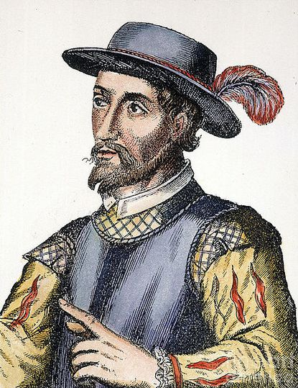
(Unknown author, Public domain, via Wikimedia Commons)
Perhaps no one previously noticed that bay’s name on that map because the technology needed to read the small letters did not exist until recent decades, MacDougald said, and the map is so rare that it might “have never been seen by Florida historians.”
The Tampa Bay History Center has approximately 5,000 maps of Florida, including “several” spanning the 1580s through the mid-1600s that reference a Bay of Juan Ponce, Kite-Powell said. Some of those maps place it near the location of present-day Tampa Bay. Others put it closer to Charlotte Harbor, Kite-Powell added.
But the History Center does not have the map that became the foundation of MacDougald’s thesis.
“That is a one-of-a-kind hand drawn manuscript map,” said Kite-Powell, who added he’d like to see all of MacDougald’s research before commenting further because he, like most historians, believes the most likely location of Ponce de León’s 1521 landing was near the Charlotte Harbor area.
“Tampa Bay and Charlotte Harbor are just slightly less than one degree of latitude apart, so they definitely fall within the margin of error of that era’s navigational tools,” he said. “I can’t wait to see the book.”
Ted Ehmann, the president of the Charlotte County Florida Historical Society, agrees that Safety Harbor is a more likely place for Ponce de León’s settlement.
“The first thing to do when scouting for a place to settle is find a source of natural water,” Ehmann said. “Charlotte Harbor didn’t have a readily available spring back then, but Safety Harbor did. I never believed Ponce de León settled here. I believe any proof that leads to Safety Harbor.”
Further adding to that belief is that Ponce de León’s 1513 expedition to Charlotte Harbor was “violently repulsed” by the Calusa Tribe, MacDougald said. “Why would he bring a settlement expedition back there? Was he that stupid?”
What’s more, Milanich said, “Charlotte Harbor was not suitable for large Spanish ships to navigate, nor was the low terrain around the harbor a good place for a Spanish settlement.”
Of course, Ponce de León’s settlement did not last long regardless of where it was.
Months after arriving in 1521, the expedition was driven away by Native Americans, the Calusa Tribe if the settlement was in Charlotte Harbor and the Tocobaga Tribe if they were in in Safety Harbor.
MacDougald is confident it was the Tocobagans.
Ponce de León was shot with a poisonous arrow and brought to Cuba, where he died.
“People came back to Spain and reported he was killed,” MacDougald said. “As a result, they named that place the Bay of Juan Ponce.”
Milanich hopes MacDougald’s work inspires other historians to reconsider the location of Ponce de León’s settlement.
“It points out the need for additional research on the 1521 Ponce expedition,” he said. “That will help us better understand the interactions between Florida Indians and the early European expeditions.”
Watch this video about Space exploration; think about and write a convincing essay about: why the explorations of the past show us how exploration, specifically in the past, is linked to the ideas in the article, and how it will play out in the future.
https://www.ted.com/talks/burt_rutan_the_real_future_of_space_exploration

CHOOSE ANY TOPIC ON EXPLORATION TO PRESENT IN CLASS, HERE ARE SOME GOOD EXAMPLES:

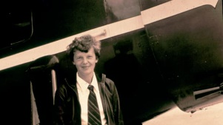

Amelia Earhart

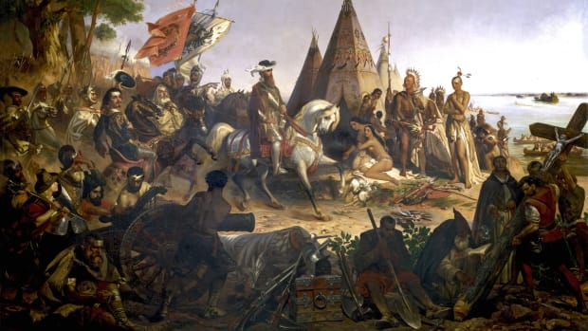
Northwest Passage

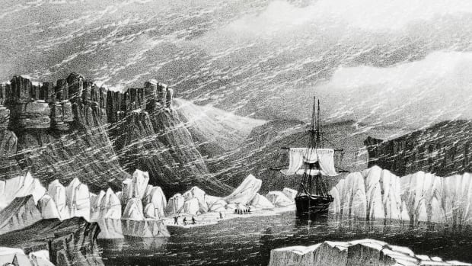

Exploration of North America
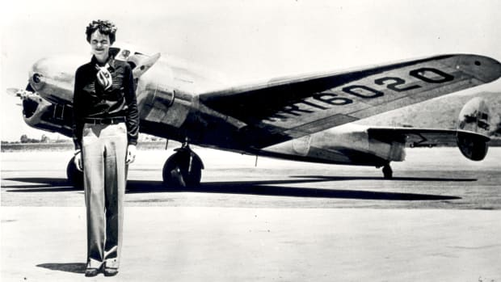

What Happened to Amelia Earhart?

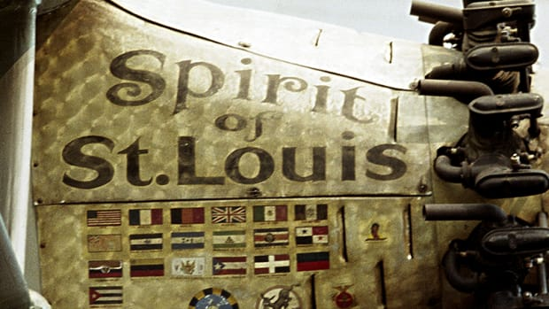

Charles Lindbergh

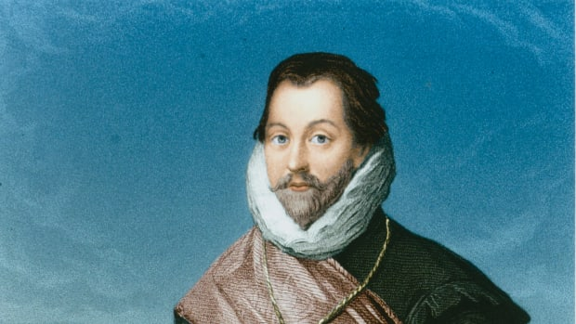

Sir Francis Drake

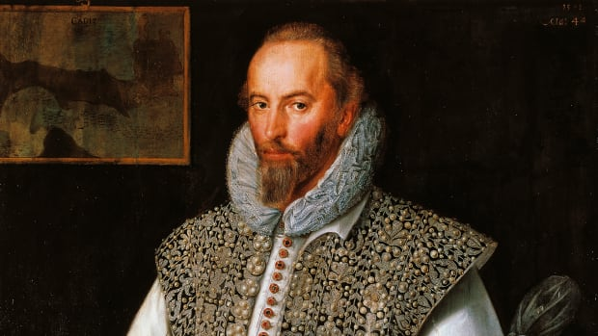

Walter Raleigh

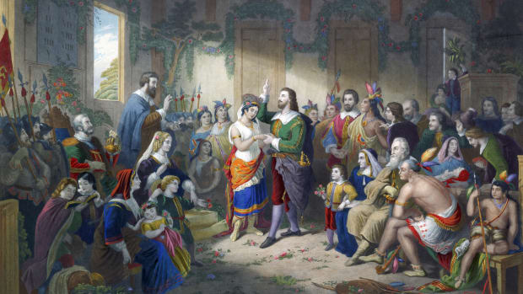

John Rolfe

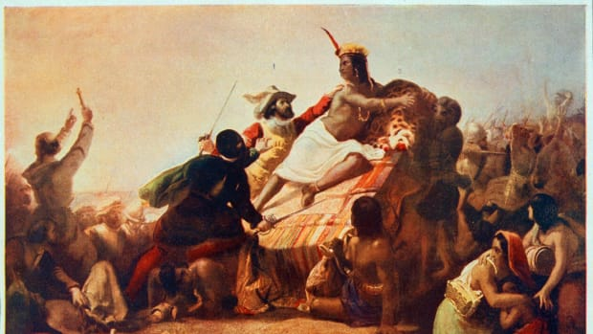

Francisco Pizarro

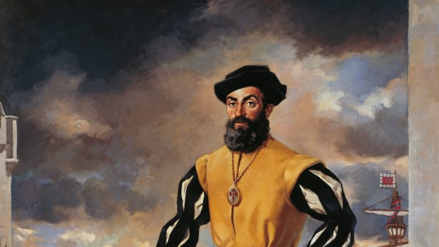

Ferdinand Magellan

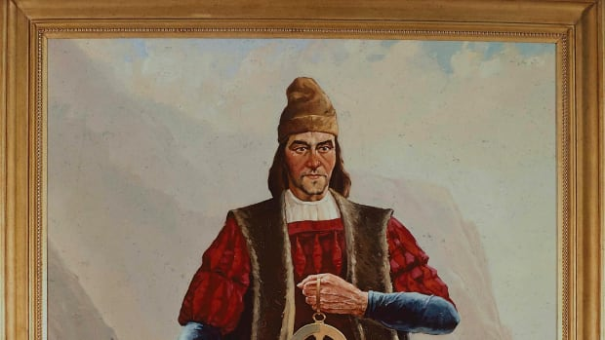

Bartolomeu Dias

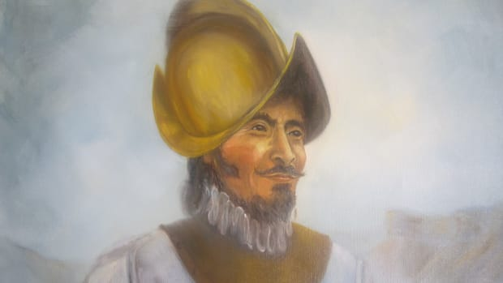

Francisco Vázquez de Coronado

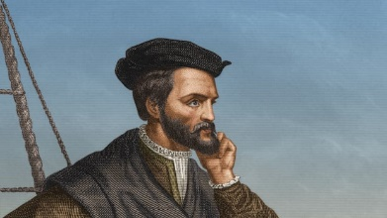

Jacques Cartier

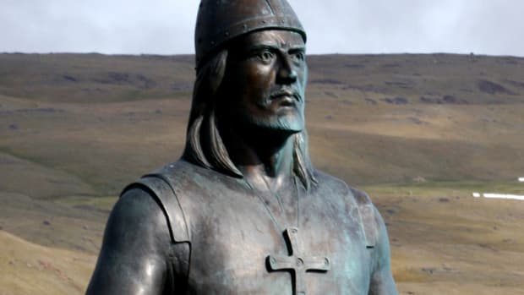

Leif Eriksson

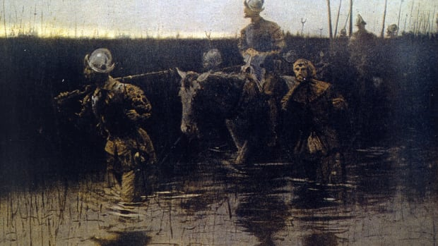

Hernando de Soto

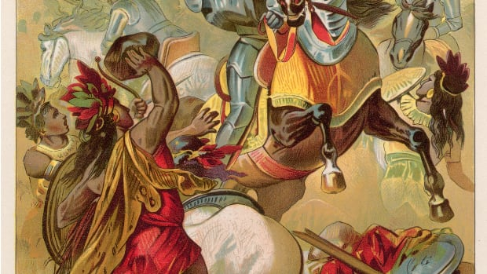

Hernan Cortes

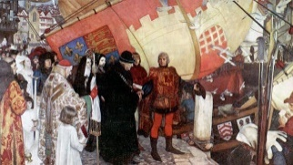

John Cabot

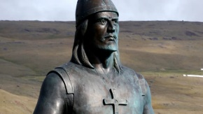

Vikings

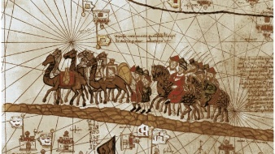

Marco Polo

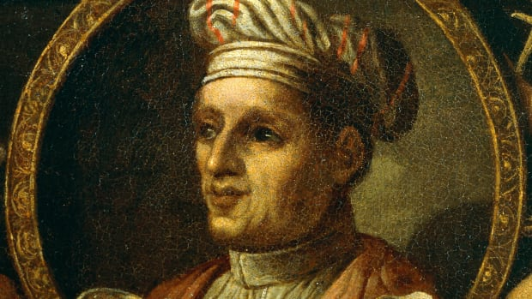

Amerigo Vespucci

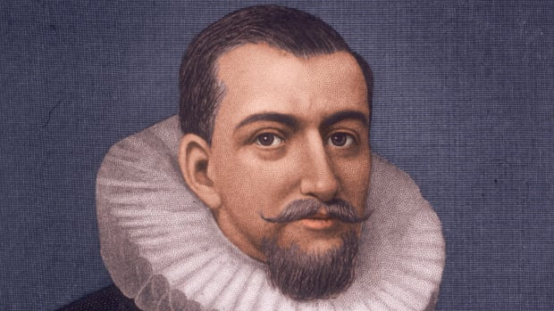

Henry Hudson

Pirates

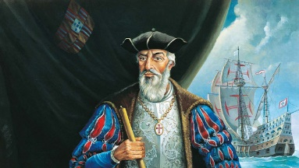

Vasco da Gama

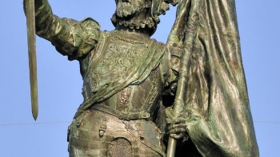

Vasco Núñez de Balboa

